MANAGEMENT INFORMATION SYSTEM

LAB EXPERIMENTS

PAGADALA ASHOK (192110152)

5) Draw a UML diagram for a food ordering system Systems. The activities of the food  ordering system are listed below. Receive the Customer food orders, Produce the  customer ordered food, Serve the customer with their ordered food, collect payment  from Customers, Store customer payment details, Order Raw Materials for food  products, Pay for Raw Materials and Pay for Labour.

**Aim:**

To develop a **UML Diagram** for a **Food Ordering System**, illustrating the interaction between customers, kitchen staff, the payment system, and suppliers.

**Procedure:**

1. **Identify Key Actors:**
   * **Customer**: Places food orders and makes payments.
   * **Kitchen Staff**: Prepares and serves food.
   * **Cashier/Payment System**: Handles customer payments and stores payment details.
   * **Supplier**: Supplies raw materials for food production.
   * **Manager**: Manages orders, inventory, and labor payments.
2. **Define the Activities (Use Cases):**
   * **Customer Use Cases:**
     + Place Order
     + Receive Food
     + Make Payment
   * **Kitchen Staff Use Cases:**
     + Prepare Food
     + Serve Food
   * **Cashier/Payment System Use Cases:**
     + Process Customer Payment
     + Store Payment Details
   * **Supplier Use Cases:**
     + Supply Raw Materials
     + Receive Payment for Materials
   * **Manager Use Cases:**
     + Order Raw Materials
     + Pay for Raw Materials
     + Pay for Labor
3. **Establish Relationships:**
   * The **Customer** interacts with the **Food Ordering System** to place an order and make payments.
   * The **Kitchen Staff** prepares and serves the food based on orders.
   * The **Cashier/Payment System** processes payments and stores details.
   * The **Manager** handles raw material procurement and labor payments.
   * The **Supplier** provides materials and receives payments from the **Manager**.

**Output:**

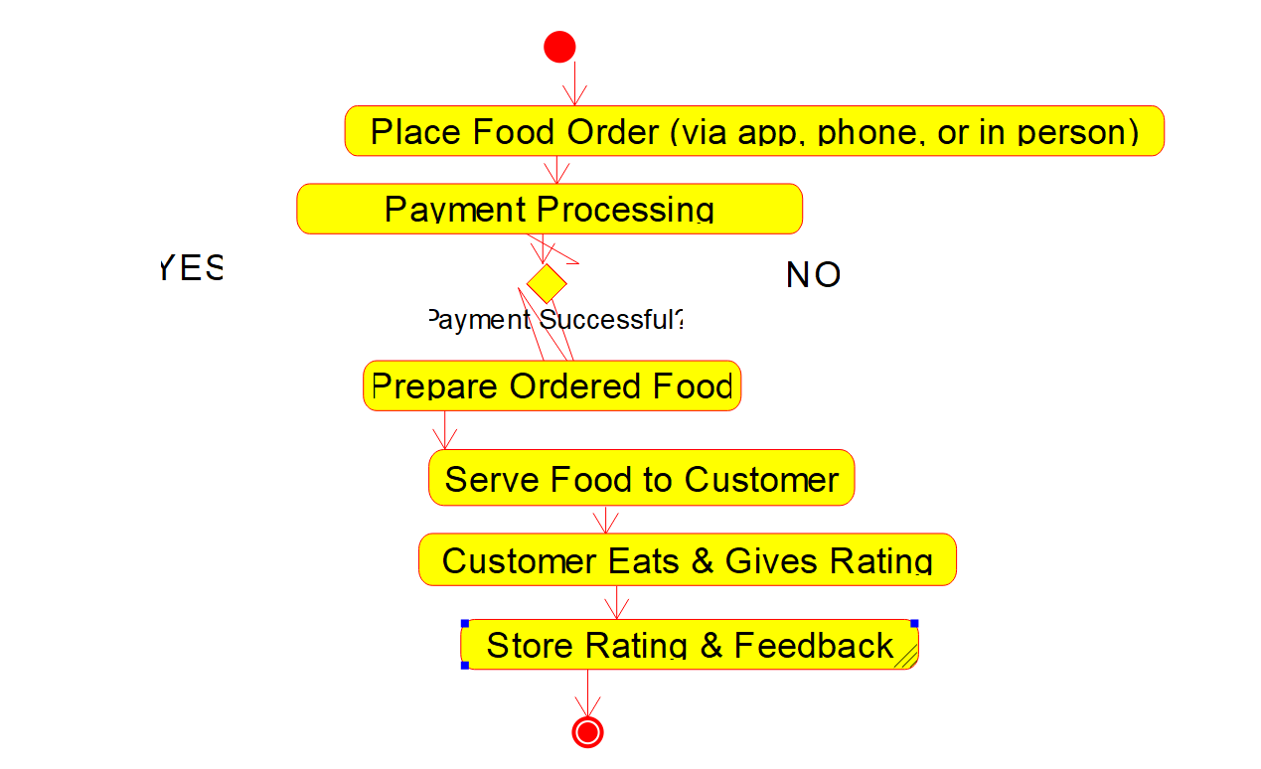

**Activity diagram**

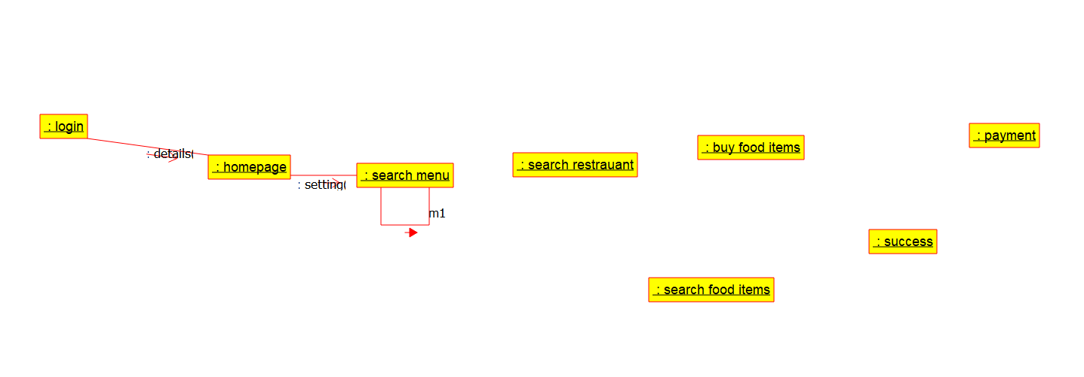

**Deployment diagram**

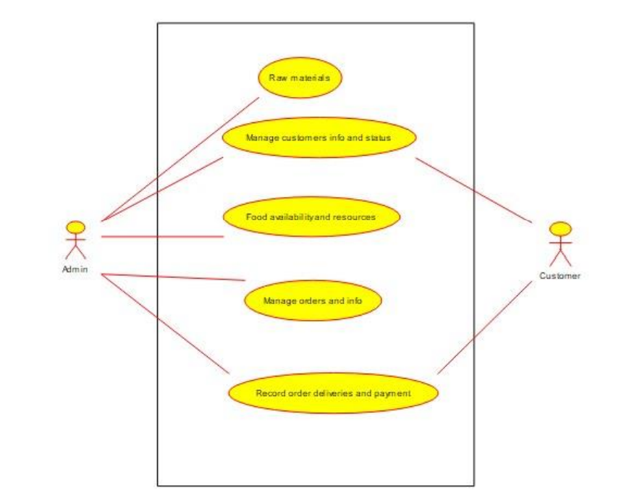

**Use case diagram**

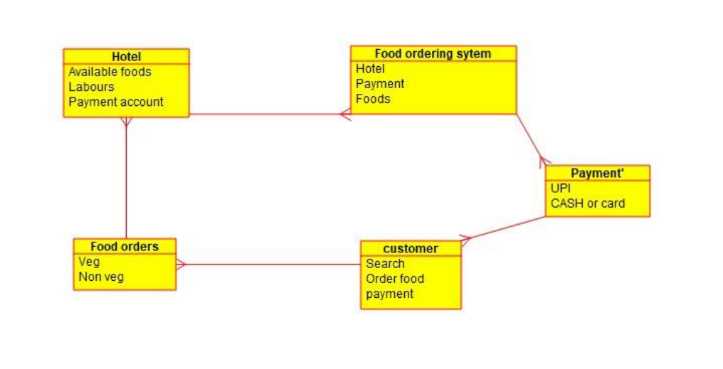

**ER diagram**

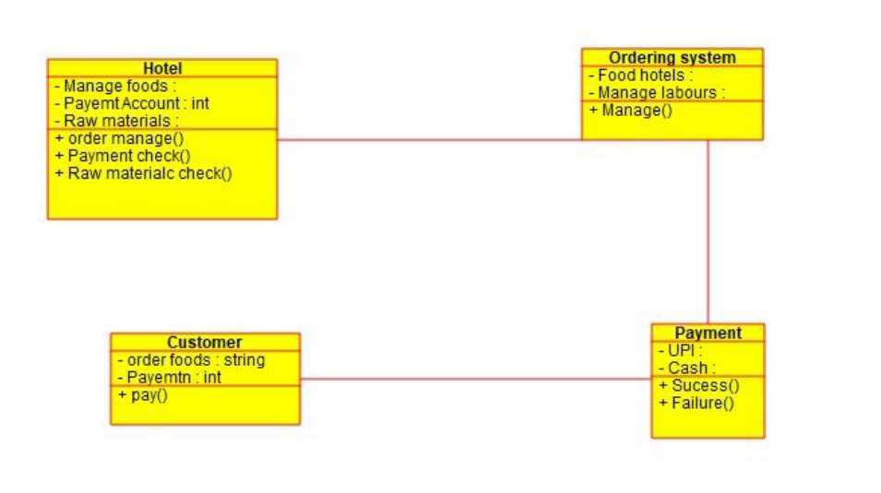

**Class diagram**

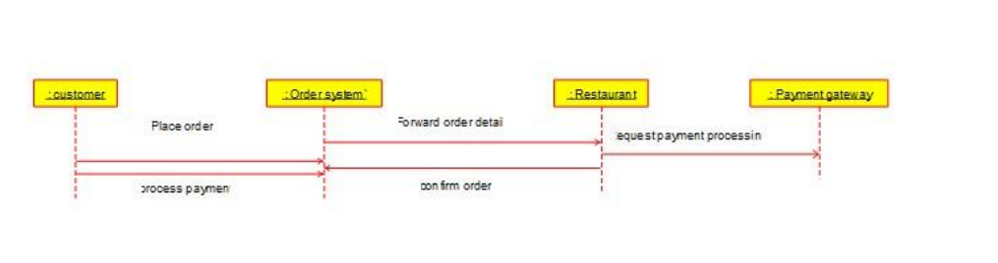

**Sequence diagram**

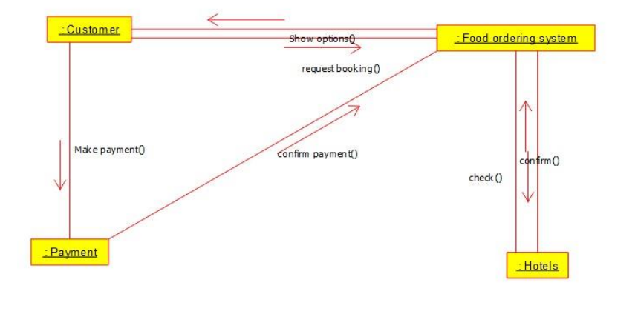

**Communication diagram**

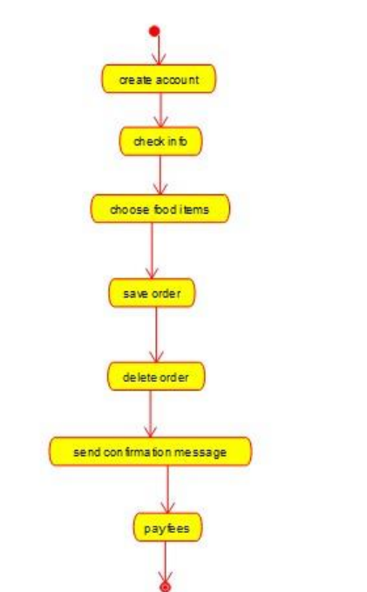

**State diagram**

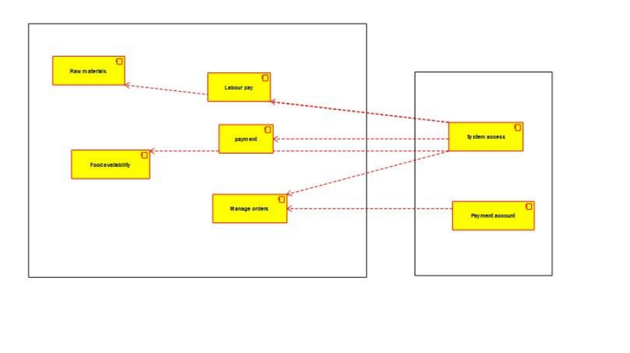

**Component diagram**

**Result:**

A **UML Use Case Diagram** will be created based on the above analysis.